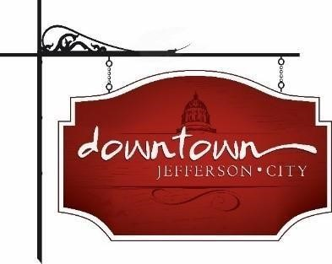. D**owntown Jefferson City**

PO Box 652, Jefferson City, MO 65102

573-291-3524

www.DowntownJeffersonCity.com

info@downtownjeffersoncity.com

facebook.com/DowntownJCMO

**BOARD OF DIRECTORS PLANNING RETREAT**

**Minutes for January 17, 2025**

Downtown Board Officers: Cara Stark-President, Gus Wagner-Vice-President, Mark Leesman-Treasurer, Jan Schumacher-Secretary

Board of Directors: Andrea Holloway, Molly Bryan, Lindsey Hammen, Dave Kemna

Ex-Officio Members: Diane Gillsepie, Susan Neill Dawdy

Meeting called to order at 8:20 am.

APPROVAL OF MINUTES –

Lindsey made a motion to approve minutes of the Dec. 3 meeting. Motion was seconded by Mark and approved.

BOARD GOVERNANCE -

Jan and Cara will work on updating the by-laws on board member requirements and changing the members section to the current structure of having supporters rather than members.

TREASURER’S REPORT – Mark Leesman

Gus made a motion to approve the financials. Lindsey seconded it. Motion approved.

Jan made a motion to accept River City Florist’s bid for flowers and watering. LIndsey seconded it. Motion carried.

Jan offered to assist Mark with Picadilly.

It was decided the association needs a five-year goal for fundraising.

EVENTS

The board discussed hosting one or more events celebrating the Jefferson City Bicentennial this year, in lieu of organizing Thursday Night Live concerts. ThNL will be re-evaluated for next year.

Gus made a motion that LIndsey would coordinate downtown’s Bicentennial events with Molly. Jan seconded. Motion carried. Jan volunteered to assist.

May 10, the day before Mother’s Day, was selected for a Spring Sip and Shop event. Molly offered to organize the event. The board decided to survey the downtown businesses to determine the best day for the November Sip and Shop.

Gus will move forward with logistics to determine if two Brunch Bashes a month will work logistically.

MAIN STREET GRANT

The deadline to apply for the next round of Missouri Main Street empowerment grants is April 18. Main Street officials will be in town Jan. 27 and can meet with any interested board members.

Gus made a motion to move forward with infrastructure to apply for the grant. Molly seconded it. Motion approved.

DOWNTOWN PROPERTIES

The possibility of doing a Hidden Spaces Tour with Historic Jefferson City was discussed.

Gus made a motion, approved by Jan, to submit paperwork to the city to have the JPfeny’s property declared a nuisance. Motion carried. It was decided to contact the property owners to inform them that Downtown is planning to take that step first.

Retreat adjourned at 11:54 am.

Respectfully submitted,

Jan Schumacher