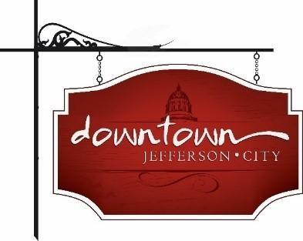
Downtown Jefferson City
PO Box 652, Jefferson City, MO 65102
573-291-3524

www.DowntownJeffersonCity.com
info@downtownjeffersoncity.com
facebook.com/DowntownJCMO

BOARD OF DIRECTORS MINUTES
April 4, 2025 meeting

Downtown Board Officers: Cara Stark-President, Gus Wagner-Vice-President, Jan Schumacher-Secretary, Mark Leesman, treasurer
Board of Directors: Matt Green, Andrea Holloway, Lindsey Hammen, Molly Bryan
Ex-Officio Members: Diane Gillsepie for CVB, Susan Neill Dawdy for chamber, Britt Smith for City of Jefferson
Staff: Dee Cook
Special Guests: Kyle Bruemmer, new City of Jefferson public works director

Meeting called to order at 9:04 am.

APPROVAL OF MINUTES
Gus Wagner made a motion to approve the February minutes. Seconded by Matt Green. Motion carried. March minutes were also approved with a motion by Gus and second by Matt.

TREASURER’S REPORT
Mark Leesman reported that expenses are in line. Membership support is at an all-time high at $15,650. Gus Wagner made a motion to approve the report, seconded by Andrea Holloway. Motion approved.

PRESIDENT’S REPORT
Cara Stark reported that we have 12 QR review signs. The first 11 businesses who sign up for Sip and Shop will receive one.

CITY OF JEFFERSON REPORT
New city Public Works Director Kyle Bruemmer was introduced. Jon Fitch is the new operations division director and Britt Smith’s replacement. The overlay program is out for advertising. There is a design contract to move the parking office to a city-owned building. A contract to design the demolition of the parking garage is on next Monday’s City Council agenda.The garage is expected to go down by March, 2026. The parking garage has switched to a new system using license plates. The city will set up a meeting with Downtown JC, the chamber, and the CVB to discuss parking plans after the demolition.
The city has also been looking at privatizing parking operations. State Sen. Hough has placed $52 million dollars in the state budget for MSP. Agreements are being prepared for the proposed conference center. Molly Bryan announced that the groundbreaking for the River Market will be in May.

CHAMBER OF COMMERCE REPORT
Susan Neill Dawdy reported the River Market will be the topic of the chamber’s next Friday Coffee. The chamber will meet next Thursday to plan the thank you event for the street crews for their hard work during inclement weather this past winter. Britt Smith mentioned what a phenomenal crew the city has.

CVB REPORT
Diane Gillespie reported that upcoming events include the swearing-in of new lawyers at the Supreme Court, a soccer tournament, and a track meet for homeschoolers that will bring an estimated 400 people. Shelbyfest will be the first weekend in May.

ADVERTISING COMMITTEE REPORT
No report

EVENT COMMITTEE REPORTS
Sip ‘n Shop: Will be on May 10. Invites have been sent to vendors. A flyer will be hand-delivered. The Fall Sip ‘n Shop will be Nov. 1.
Brunch Bash: Food trucks have signed up. First one will be April 27.
Piccadilly: There will be a planning committee for Piccadilly this month.
Living Windows: Will be held Friday, Dec. 5. May start planning a little earlier this year.
Bicentennial: City will have a free event at the Amphitheater on July 3. The Historic City of Jefferson will have a speaker series in the fall.
Hidden Spaces: Cara is getting some spaces secured
Thursday Night Live: We should all share the same message on this event while it is on hiatus.

UNFINISHED BUSINESS
Missouri Main Street grant: Comments on the application are due to Cara by April 11. The site visit will be April 28.
The next DT membership meeting will be at 3 pm on April 8 at Bar Whiskey to provide an opportunity to meet new city officials and to have a send off for Brit Smith

The next board meeting will be Friday, May 9 at 9 am.

Meeting adjourned at 10:08 am.

Respectfully submitted,

Jan Schumacher

