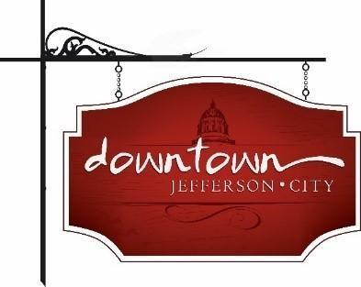
. Downtown Jefferson City
PO Box 652, Jefferson City, MO 65102
573-291-3524

www.DowntownJeffersonCity.com
info@downtownjeffersoncity.com
facebook.com/DowntownJCMO

BOARD OF DIRECTORS MEETING
Minutes for December 2, 2024

Downtown Board Officers: Cara Stark-President, Gus Wagner-Vice-President, Mark Leesman-Treasurer, Jan Schumacher-Secretary
Board of Directors: Andrea Holloway, Molly Bryan
Ex-Officio Members: Britt Smith, Susan Neill Dawdy

Meeting called to order at 3:03 pm.

SECRETARY’S REPORT –
Gus made a motion to approve minutes of the Oct. 1 meeting. Motion was seconded by Molly and approved.

TREASURER’S REPORT – Mark Leesman
Mark reported that we have broken a five-year record of number of supporters/members. On the financial highlights he noted that the River City Florist bid for plants has gone up from $26,970 to $28,000 this year. This covers plants and watering for hanging baskets and planters in Spring, Summer and Fall. It was suggested that the County (Sam Bushmann or Sheriff Wheeler) be approached about paying for plants and watering in the 300 block since they own several buildings there. The Parks Division cleans out the tree wells and takes down dead trees.

PRESIDENT’S REPORT - Cara Stark
The Strategic Planning Board Retreat has been moved to January to allow more people to attend. Cara will send out dates. It will be in lieu of the regular January board meeting.

VICE-PRESIDENT’S REPORT – Gus Wagner
Gus reported that all ISP service providers except Mediacom are planning to attend the Internet Summit on Dec. 4.It will be a Happy Hour format at Roaming Spirits.

CITY OF JEFFERSON REPORT – Britt Smith
The City is transitioning to digital permits for parking in the garage using license plate numbers in January, followed by digital permits in the parking lots. He asked about the possibility of having lights around light poles, perhaps year round. The matter will be discussed in the Spring.
Gus mentioned the possibility of closing the upper floors of the garage after hours to curb use by those there for reasons other than parking. Having a police substation there was also mentioned.

Cara reported that an assessment contractor has determined that the JC Penney building is dangerous, and the process of addressing that has begun.

ADVERTISING REPORT - Gus Wagner
Gus reported that in 2024 the downtown website has been more SEO-friendly. We’ve had 5,500 visits this year. 1,800 were for Sip and Shop, 945 were the home page and 249 were the Brunch Bash.

EVENT COMMITTEE REPORTS
Living Windows – Dec. 6 - Cara reported that the drone show was too expensive to put on this year but that there will be new attractions, including a snow play area and roaming dinosaur. The Convention & Visitors Bureau is sponsoring custom mugs. The first 300 people who show a receipt of purchasing an item downtown that night will receive one. Gus asked about the possibility of selling 50-50 tickets but it was decided not to do that this year.

Andrea made a motion to adjourn, seconded by Molly. Meeting adjourned at 4:13 pm.

Respectfully submitted,

Jan Schumacher

