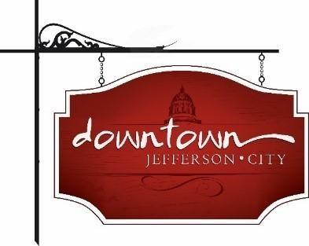
. Downtown Jefferson City
PO Box 652, Jefferson City, MO 65102
573-291-3524

www.DowntownJeffersonCity.com
info@downtownjeffersoncity.com
facebook.com/DowntownJCMO

BOARD OF DIRECTORS MINUTES
February 4, 2025 meeting

Downtown Board Officers: Cara Stark-President, Gus Wagner-Vice-President, Jan Schumacher-Secretary
Board of Directors: Andrea Holloway, Lindsey Hammen, Dave Kemna
Ex-Officio Members: Diane Gillsepie

Meeting called to order at 3:04 pm.

APPROVAL OF MINUTES
Gus Wagner made a motion to approve minutes of the Jan. 7 board retreat. Motion was seconded by Lindsey Hammen and approved.

TREASURER’S REPORT
Mark Leesmanwill email his report to the board.

PRESIDENT’S REPORT
Cara Stark said work is continuing on the by-laws and suggested revisions will be sent one week before the next board meeting.
Board member roles were discussed. Board member event organizers will be:
- Living Windows: Andrea Holloway
- Sip and Shops (Mother’s Day weekend and Fall): Molly Bryan & Lindsey Hammen
- Piccadilly: Mark Leesman & Jan Schumacher
- Property Owner/Business Owner Social: Gus Wagner & Jan Schumacher
- Living Windows in July: Andrea Holloway & Cara Stark
- Bicentennial events: Molly Bryan & Lindesy Hammen
- Brush Bash series: Gus Wagner
- Annual Membership Luncheon: Mark Leesman & Gus Wagner
Mark Leeman and Gus Wagner will work on sending an annual letter to retain supporters and attract new supporters.
The Downtown liaison for city, county and state is the board president de facto or his/her designated representative
Board requirements for Piccadilly:
- Attend event
- Identify a table sponsor
- Find at least 2 auction items
Cara Stark will meet with Mayor Fitzwater and Brian Crane re: who will fill the city’s ex-officio role with Britt retiring and also funding from the city

VICE-PRESIDENT REPORT
Gus Wagner reported that Downtown will consider expanding snow removal. Cara will survey downtown businesses with a “Looking Ahead to 2025” survey.

CHAMBER OF COMMERCE REPORT
Susan Neill Dawdy reported she will be working with Molly Bryan and Julie Allen to have a Spring Thaw thank you for snow removal crews - about 50 people.

ADVERTISING COMMITTEE REPORT
Gus Wagner announced that we have 18,000 fans on Facebook and 1,100 text program subscribers.

EVENT COMMITTEE REPORTS
Piccadilly: Cara Stark will send a list of potential dates for Piccadilly to the entire board.
Bicentennial partnership with the city: Lindsey Hammen will chair, with assistance from Dave Kemna and Molly Bryan. A date will be determined by the group
Thursday Night Live: Cara Stark will meet with Angela to discuss.

UNFINISHED BUSINESS
Conference center: A report was made to the City Council and is on the JCREP website.

Meeting adjourned at 4:07 pm

Respectfully submitted,

Jan Schumacher

