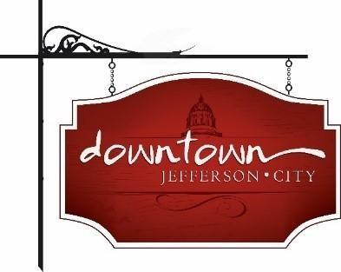
Downtown Jefferson City
PO Box 652, Jefferson City, MO 65102
573-291-3524

www.DowntownJeffersonCity.com
info@downtownjeffersoncity.com
facebook.com/DowntownJCMO

BOARD OF DIRECTORS MINUTES
March 4, 2025 meeting

Downtown Board Officers: Cara Stark-President, Gus Wagner-Vice-President, Jan Schumacher-Secretary, Mark Leesman, treasurer
Board of Directors: Andrea Holloway, Lindsey Hammen, Molly Bryan
Ex-Officio Members: Diane Gillsepie for CVB, Susan Neill Dawdy for chamber
Staff: Dee Cook
Special Guests: Councilman Mike Lester, City Planning Director Clint Smith, City Building Inspector Dave Helmick, Rachel Senzee, City’s Neighborhood Services Supervisor

Meeting called to order at 3:04 pm.

At the beginning of the meeting, city staff made a presentation on challenges related to deteriorating downtown buildings.

APPROVAL OF MINUTES
Minutes from the February meeting will be sent by email and approved at the March meeting.

TREASURER’S REPORT
Mark Leesman introduced Dee Cook who was hired to do the books for the Downtown association. He reported that we have 85 supporters this year, bringing in $15,000. This includes 27 new or returning members. He noted that our social media presence makes a huge difference. We will have a membership drive in the summer. Molly Bryan made a motion to approve. Seconded by Lindsey Hammen. Motion approved.

BOARD RECRUITMENT
Gus Wagner reported that we have one vacancy on the board, with one more coming. The application is online. It would be good to have a property owner.

PRESIDENT’S REPORT
Cara Stark said the bylaws will be reworked when we go through the organizational introspection with the Main Street grant.

VICE-PRESIDENT REPORT
Gus Wagner gave an update on the Second Story project, noting we’ll start reaching out to property owners from our list. The goal is to bring more businesses and residents downtown.
He also proposed a QR review program which would be distributed to Downtown supporters, tying in with Sip and Shop. Lindsey Hammen made a motion to approved. Mark Leesman seconded it. Motion approved.

CITY OF JEFFERSON REPORT
The city’s ex-officio rep on the board will be Molly Bryan when Britt Smith retires April 11. It was announced that demolition of the parking garage will be going out to bid. An update on the River Market will be presented at the next City Council meeting. Contracts are underway for the Bicentennial Downtown concert event.

CHAMBER OF COMMERCE REPORT
Susan Neill Dawdy reported there will be an update on the conference center at the Friday Coffee. The chamber is working on a thankyou for the snow removal crew.

CVB REPORT
Diane Gillespie reported there will be a USA gymnastics event on March 28, expected to bring in 900 people.

ADVERTISING COMMITTEE REPORT
No report

EVENT COMMITTEE REPORTS
No reports.

UNFINISHED BUSINESS
No unfinished busines.

Meeting adjourned at 4:25 pm

Respectfully submitted,

Jan Schumacher

