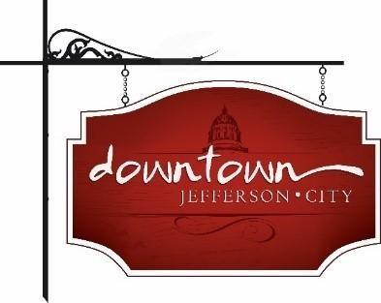
Downtown Jefferson City
PO Box 652, Jefferson City, MO 65102
573-291-3524

www.DowntownJeffersonCity.com
info@downtownjeffersoncity.com
facebook.com/DowntownJCMO

BOARD OF DIRECTORS MINUTES
May 9, 2025 meeting

Downtown Board Officers: Cara Stark-President, Gus Wagner-Vice-President, Jan Schumacher-Secretary, Mark Leesman-treasurer
Board of Directors: Andrea Holloway, Lindsey Hammen, Dave Kemna

Meeting called to order at 9:05 am.

APPROVAL OF MINUTES
Gus Wagner made a motion to approve the February minutes. Seconded by Lindsey Hammen. Motion carried.

TREASURER’S REPORT
Mark Leesman announced that we have our first $1,000 investing partner - Google Fiber. Last year we added “investing partner” as a new category. We now have over $15,000 in supporters.
Mark also said we still owe $11,000 for lights. He noted that we’re $17,000 to the good on the DTJC line item compared to 2024.
Lindsey Hammen made a motion to approve the report, seconded by Gus Wagner. Motion approved.
Mark presented the budget for the upcoming fiscal year. He noted he didn’t include anything for Thursday Night Live since we won’t be having it this year. Dave Kemna made a motion to approve the budget. It was seconded by Angela. Motion carried.
Gus asked about getting an audit done. Mark said he will be looking into it.

PRESIDENT’S REPORT
Cara Stark reported that she and Gus Wagner met with JCPD about having more presence downtown during the summer. They were very receptive. She also said the department has hired a second community relations officer who will be attending our next membership meeting.
Cara and Gus also had a productive meet with the city public works director and parks director to discuss AARP funds, tree wells and sidewalks. The city will be replanting numerous trees throughout the city.
Cara said we had a request to be a $1,000 sponsor for Salute to America. Gus made a motion to approve. Dave seconded the motion. Motion carried.
Cara asked the board to review the application for a vacant board position submitted by Dawn Sweazea to vote on via email next week. She also reported that Molly Bryan will be moving to serve as the ex-officio board member from the city. Gus made a motion to approve. It was seconded by Dave. Motion approved.
Cara also said that Susan Dawdy Smith requested $200 from us to be used for ice cream thank-you for the city street crew. Gus made a motion to approve. Lindsey seconded it. Motion carried.

VICE-PRESIDENT REPORT
Gus reported that the next membership meeting will be a lunch and learn with Bluebird Fiber next week. A Zoom business meeting will be held May 20 from noon to 1 pm to discuss DT business with sponsors.

CITY OF JEFFERSON REPORT
Cara reported that there will be a Bicentennial meeting later today which she will attend.

CHAMBER OF COMMERCE REPORT
No report

CVB REPORT
Cara said Diane Gillespie asked her to announce that upcoming events include MSHSAA state track meet, Capital City Race half-marathon and ribbon cuttings for the River Market and the soccer complex.

ADVERTISING COMMITTEE REPORT
No report

EVENT COMMITTEE REPORTS
Sip ‘n Shop is this Saturday.
Brunch Bash starts May 18.
The first Piccadilly organizational meeting will be May 19.
Gus reported we are making great progress in getting the lights for Christmas in July.

UNFINISHED BUSINESS
We have signed the agreement with Missouri Main Street. The town hall will be held in the Fall. The Main Street state conference will be held in St. Charles July 22-24. Cara will send out a list of Missouri Main Street events for board members to sign up for.

Meeting adjourned at 10:08 am.

Respectfully submitted,

Jan Schumacher

