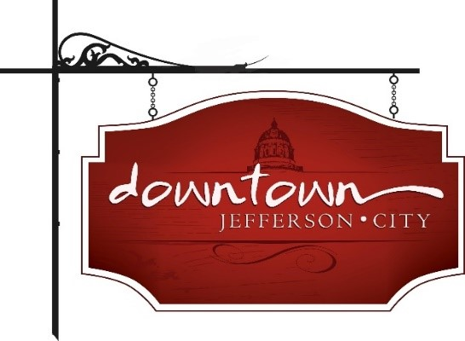

Downtown Jefferson City
PO Box 652
Jefferson City, MO 65102
573-291-3524

Jefferson City Mayor and City Council
320 E. McCarty Street
Jefferson City, MO 65101

Dear Mayor and Members of the City Council,
On behalf of Downtown Jefferson City, Inc., I am writing to express our support for placing a lodging tax extension on the November 4, 2025 ballot. We fully endorse the effort led by the Jefferson City Convention & Visitors Bureau (JCCVB) to extend the existing 7% lodging tax for an additional 25 years beyond its current expiration date of April 30, 2035.
Since its original approval by voters in 2011, the lodging tax has been a vital funding mechanism for both tourism promotion and the long-term vision of a conference center in Jefferson City. With 3% of the tax supporting the essential operations of the JCCVB and 4% dedicated to the conference center fund, this revenue has served as a cornerstone for efforts to position our city as a regional tourism and convention destination.
Extending the tax beyond 2035 provides the financial certainty necessary to increase bonding capacity for the construction of a future conference center and to invest in other tourism-related infrastructure. Importantly, this tax is paid by visitors to our community - through hotel and short-term rental stays -and not by local residents.
We respectfully urge the City Council to advance this measure to the voters for consideration on the November 2025 ballot. Doing so ensures we are proactively planning for the future of Jefferson City as a welcoming, thriving, and competitive destination.
Sincerely,

